PRAYERS FOR THE EIGHT DAYS of PRAYER FOR CHRISTIAN UNITY
ASCENSION SUNDAY: You shall also love the stranger, for you were strangers in the land of Egypt
Leviticus 19:33-34 You shall love the alien as yourself.
Today’s Reading: Mark 16:15-20 Go out to the whole world; proclaim the Good
News to all creation.
Reflection
Our common Christian experience of God’s saving action goes together with remembering both alienation and estrangement. God has restored our dignity in Christ, and made us citizens of the kingdom, not because of anything we did to deserve it but by his own free gift in love. We are called to do likewise, freely, and motivated by love. Christian love is to love like God. To love like God is to recognize dignity and to give dignity, thereby to helping to bring healing to the broken human family. By doing so, we are proclaiming by word and deed the Good News to all creation.

Prayer
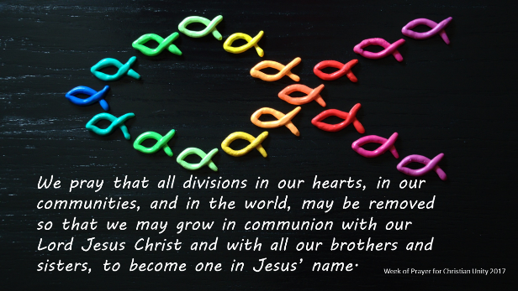
Eternal God,
You belong to no culture and land but are Lord of all,
you call us to welcome the stranger in our midst.
Help us by your Spirit,
to live as brothers and sisters,
welcoming all in your name,
living in the justice of your kingdom,
and proclaiming the Good News to all.
This we pray in Jesus’ name, Amen.

MONDAY: No longer as a slave but a beloved sibling
Philemon 1:16 No longer as a slave but more than a slave, beloved sibling.
Today’s reading: John 16:29-33 I have told you all this so that you may find peace in me.

Reflection
One of the first things we learn about God in the Hebrew and Christian Bible is that God created humankind in his own image. However, this profound and beautiful truth has often been obscured or denied throughout human history. Paul, made bold in Christ, describes the once-enslaved Onesimus as ‘a beloved brother’, transgressing the norms of his society and affirming Onesimus’s humanity. Christian love must always be a courageous love that dares to cross borders, recognising in others a dignity equal to our own. Like St Paul, Christians must be ‘bold enough in Christ’ to raise a united voice in clearly recognising all persons as their neighbours and their beloved brothers and sisters, and so work together to end modern-day slavery. In doing so we will find the peace that Christ offers.

Prayer
Gracious God,
draw near to those who are victims of human trafficking,
assuring them that you see their plight and hear their cry.
May your Church be united in compassion and courage to work for that day
when no one will be exploited
and all will be free to live lives of dignity and peace.
This we pray in the name of the Triune God
who can do immeasurably more than we can ask or imagine. Amen.

TUESDAY: Your body is a temple of the Holy Spirit
Exodus 3:4-10 God frees those who are in human bondage
Today’s Reading: John 17: 1-11 I pray for them;…because they belong to you

Reflection
God’s revelation to Moses at the burning bush was a powerful declaration of God’s will to free people from bondage. God observed their misery, heard their cry, and so came to deliver them. God still hears the cry of the poor. Christians must work together for the kind of society that upholds human dignity and does not put a stumbling block before any of God’s little ones, but, rather, enables them to live in the freedom which is God’s will for them. All people belong to God and as God’s people we pray for all that human dignity is respected.

Prayer
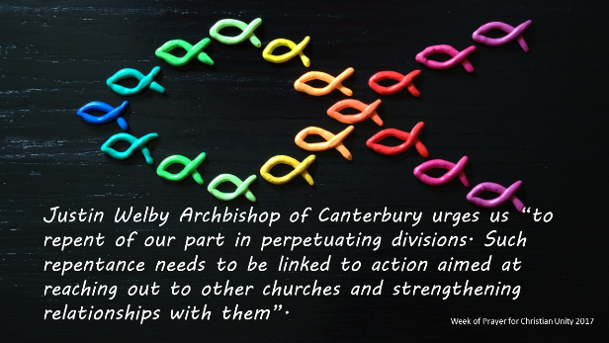
By your heavenly grace, O God,
restore us in mind and body,
create in us a clean heart and a pure mind
that we may give glory to your Name.
May the churches attain unity of purpose
for the upholding of your people,
through Jesus Christ
who lives and reigns with you
in the unity of the Holy Spirit,
for ever and ever. Amen.

WEDNESDAY: Hope and Healing
Psalm 34:1-14 Seek peace, and pursue it.
Today’s reading: John 17:11-19 Keep those you have given me true to your name, so that they may be one like us.
Reflection
The kingdom which God promised, the kingdom which Jesus proclaimed and made manifest in his ministry, is a kingdom of unity, righteousness, peace and joy in the Holy Spirit. How can Christians bring the light of Jesus to those living in the darkness of violence? What sense of hope can Christians offer? It is a sad reality that division among Christians is a counter-sign, which hampers the communication of hope. However, the quest for peace and reconciliation between the different churches and confessions is the opposite of that. When Christians strive to be one in a world of conflict, they offer the world a sign of reconciliation. Christians who refuse to enter a logic of privilege and status, who refuse to demean others and their communities, give witness to the peace of God’s kingdom. This is a peace the world needs, and one which brings healing and comfort to those afflicted by violence.

Prayer
God of all comfort and hope,
your resurrection defeated the violence of the cross.
As your people,
may we be a visible sign of unity and peace
that the violence of the world will be overcome.
This we pray in the name of our risen Lord. Amen.

THURSDAY: Hark, the cry of my poor people from far and wide in the land!
Psalm 145:9-20 The Lord upholds all who are falling
Today’s reading: John 17:20-26 May they all be one…so that the world may believe that it was you who sent me.
Reflection
The Hebrew Scriptures tell that God always hears the cries of the poor those in tumult and chaos. The Lord who upholds the falling not only hears, but responds. Through their encounter with Jesus, the poor lives are radically transformed. It should be the same when the poor encounter Jesus through the presence of the Christian. The disunity of Christians can become part of the world’s tumult and chaos. Our divisions can drown out the cry of the poor. However, when we are united we become more fully Christ’s presence in the world, better able to hear, listen and respond. Rather than increasing the volume of discord, we are able to truly listen and so discern the voices that most need to be heard.

Prayer
Loving God,
you lift up the poor and distressed
and uphold their dignity.
Hear now our cries for the poor of our world,
restore their hope and lift them up,
that all your people may be one.
This we pray in Jesus name.
Amen.

FRIDAY: Let us look to the interests of others
Psalm 82 Maintain the right of the lowly and the destitute
Today’s reading: John 21: 15-19 Feed my lambs, feed my sheep.

Reflection
The witness of the Scriptures is consistent that God always makes a preferential option for the poor: the right hand of God acts for the powerless against the powerful. Similarly, Jesus consistently warns against the dangers of greed. Despite these warnings, however, the sin of greed often infects our Christian communities and introduces a logic of competition: one community competing against the next. For our different churches and confessions, to be rich in the sight of God is not a case of having many members belonging – or donating – to one’s own community. Rather, it is to recognise that as Christians we have countless brothers and sisters right across the world, united across the economic divisions of ‘North’ and ‘South’. Conscious of this fraternity in Christ, Christians can join hands in promoting justice for all.

Prayer
Almighty God,
give courage and strength to your church
to continually proclaim justice and righteousness
in situations of domination and oppression.
As we celebrate our unity in Christ,
may your Holy Spirit help us
to look to the needs of others.
Amen.
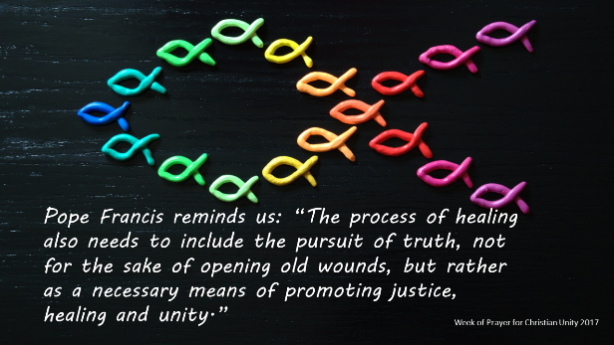
SATURDAY: Building family in household and church
Psalm 127 Unless the Lord builds the house, those who build it labour in vain.
Today’s reading: Acts 28: 30-31 Paul remained in Rome, welcoming all and proclaiming the kingdom of God
Reflection
Families are of central importance for the protection and nurture of children. The Scriptures view children as a blessing and as hope for the future. For the Psalmist, they are ‘like arrows in the hand of a warrior’. As Christians, we share a common calling to welcome all and to live as supportive family networks, relying on the strength of the Lord for the task of building strong communities in which children are protected and can flourish.

Prayer
Gracious God,
you sent your son to be born in an ordinary family
with ancestors who were both faithful and sinful.
We ask your blessing upon all families
within households and communities.
We pray especially for the unity of the Christian family
so that the world may believe.
In Jesus’ name we pray,
Amen.

PENTECOST SUNDAY: He will gather the dispersed… from the four corners of the earth
Ephesians 2:13-19 He has broken down the dividing wall…
Today’s reading: Acts 2:1-11 ...from every nation under heaven, they heard
the disciples speak in their own language.
Reflection
Throughout the biblical narrative of salvation history, an unmistakable motif is the unrelenting determination of the Lord to form God’s people. The formation of such a people united in a sacred covenant with God is integral to the Lord’s plan of salvation and to the glorification of God.
When Christians discover their unity in Jesus they participate in Christ’s glorification in the presence of the Father, with the same glory that he had in the Father’s presence before the world existed. And so, God’s covenanted people must always strive to be a reconciled community - one which itself is an effective sign to all the peoples of the earth of how to live in justice and in peace.

Prayer
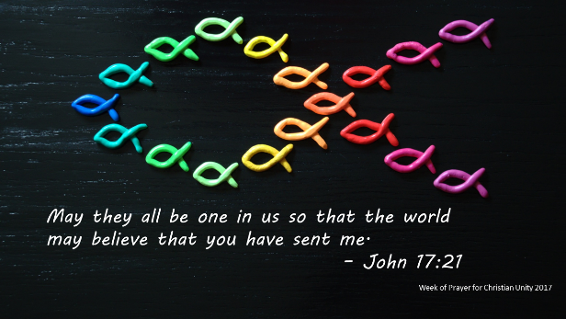
Lord,
we humbly ask that, by your grace,
the churches throughout the world
may become instruments of your peace. Through their joint action as ambassadors
and agents of your healing, reconciling love
among divided peoples,
may your Name be hallowed and glorified.
Amen.
For use in Christian communities especially during the Week of Prayer for Christian Unity 13-20 May 2018 when appropriate e.g. post communion, the beginning of meetings, personal reflection.

